Chapter 2, Problem 17.

Obtain v₁ through v₃ in the circuit in Fig. 2.81.

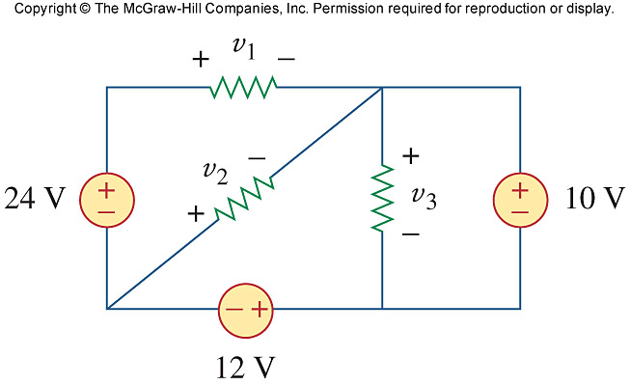
Figure 2.81
For Prob. 2.17.

